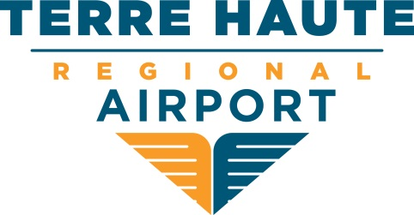

Board of Directors
Regular Session

CANCELLED: September 13, 2017 at 8:00 am EST

581 South Airport Street ∙ Terre Haute, Indiana 47803
812-877-2524 Office ∙ 812-877-3853 Fax
www.huf.com

